Assessment: The Arctic Hare
We will tell you about the Arctic Hare and how its traits and behavior fit into its habitat. But when the habitat changes, some of the traits of the Arctic Hare might not help it survive. You will be writing and drawing your ideas about this question.

The Arctic Hare lives in a cold, dry habitat, which has almost no trees. The habitat where the Arctic Hare live is called Tundra. Many hares live near the city Utqiaġvik, also called Barrow, Alaska.
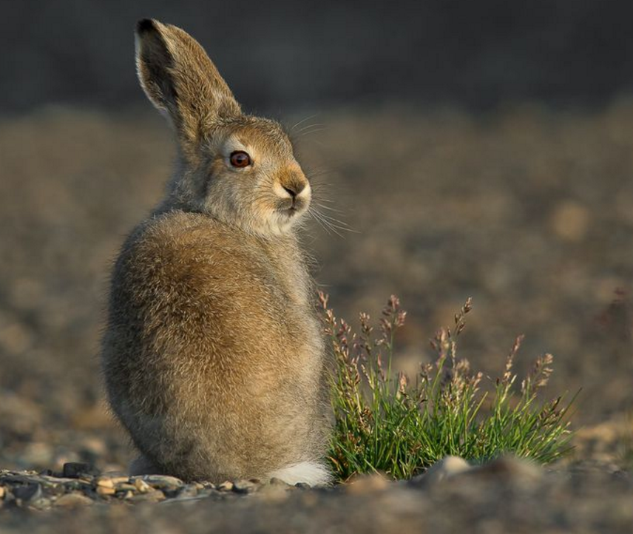

Arctic Hare in the summer
This picture was taken in July.

What characteristics of the Arctic Hare do you notice?

______________________________________________________________________
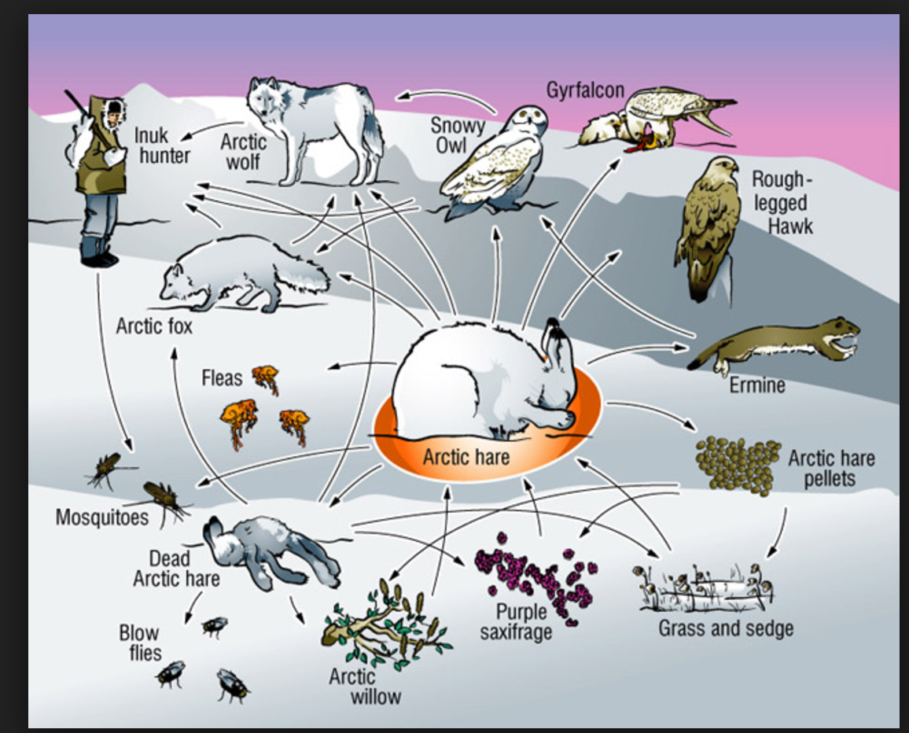

The model shows where the Arctic Hare fit into the food web in the Tundra.

The Arctic Hare have to blend in with the habitat to escape the Snowy Owl, who catch the Arctic hare and eat them.

Arctic Hare are animals that like to be alone, but sometimes they can be found huddled in large groups of several hundred. This huddling is a social behavior that is likely to happen in December, January and February.

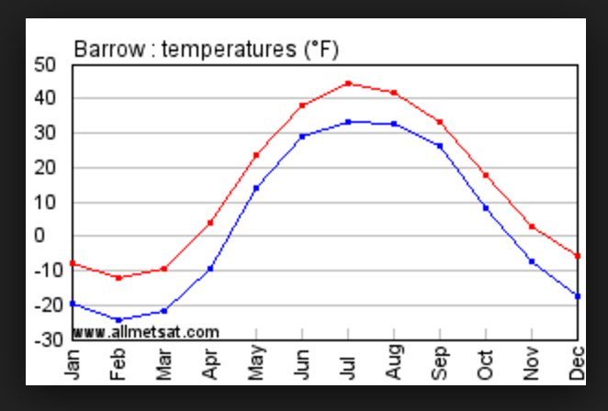

Take a look at the average monthly temperature graph and think about why this behavior might make sense.
The red line shows the highs and the blue line shows the lows.

Arctic Hare in the Winter:
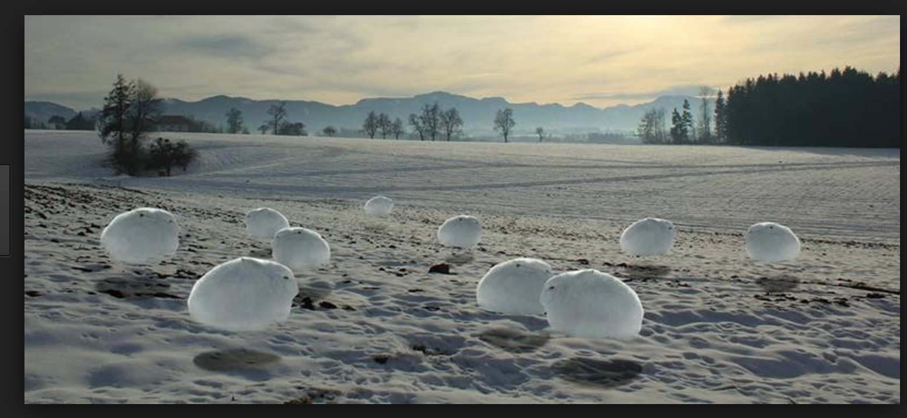
Here is a picture of the Arctic Hare in the winter. It looks different from the summer. Think about how the Arctic Hare have different structures, behaviors, and characteristics in the winter than in the summer.
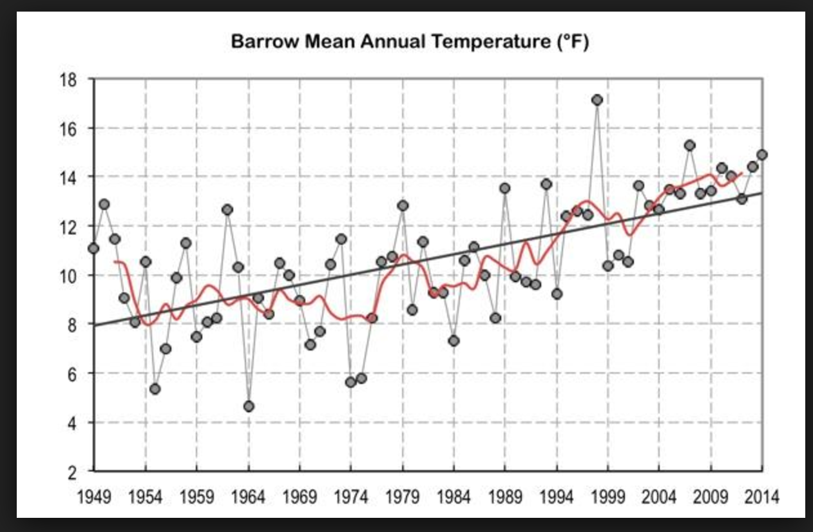
The climate in Barrow has been changing over the past 60 years. The graph above shows the average annual temperature in Barrow, from 1949 through 2014.

Think about how the temperature is changing and how the change in temperature affects the survival of the Arctic hare.

Question: Think about what you know about how species survive.

Make a prediction about how the hare’s 1. behavior, 2. its traits (characteristics), and
3. Its chances for survival might change in the next 10 years as the temperature continues to change. Use evidence to support your thinking. Make sure you use more than one of the sources above for your answer.

Develop a model that shows your thinking and aligns to your explanation. (You can use the back of this page.) Your model should show how the change in temperature is impacting the hare. The title of the model is the question that you are trying to answer.

____________________________________________________________________________

___________________________________________________________________________
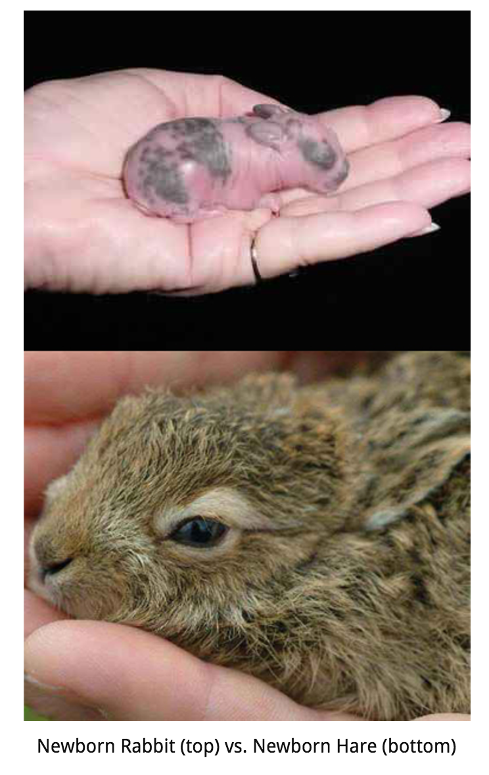
Hares are not the same as rabbits who often live as pets in people’s homes.

The picture shows a rabbit on the top and a hare on the bottom. They are both pictures of newborns. Arctic Hares live on their own almost as soon as they are born, unlike rabbits who depend on care of the mother. The hare looks really different from the rabbit when it is born.

Use information from the text and pictures and all of the sources to explain why the hare might have a life cycle that is different in some ways from the rabbit.

_________________________________________________________________________

_________________________________________________________________________

________________________________________________________________________

