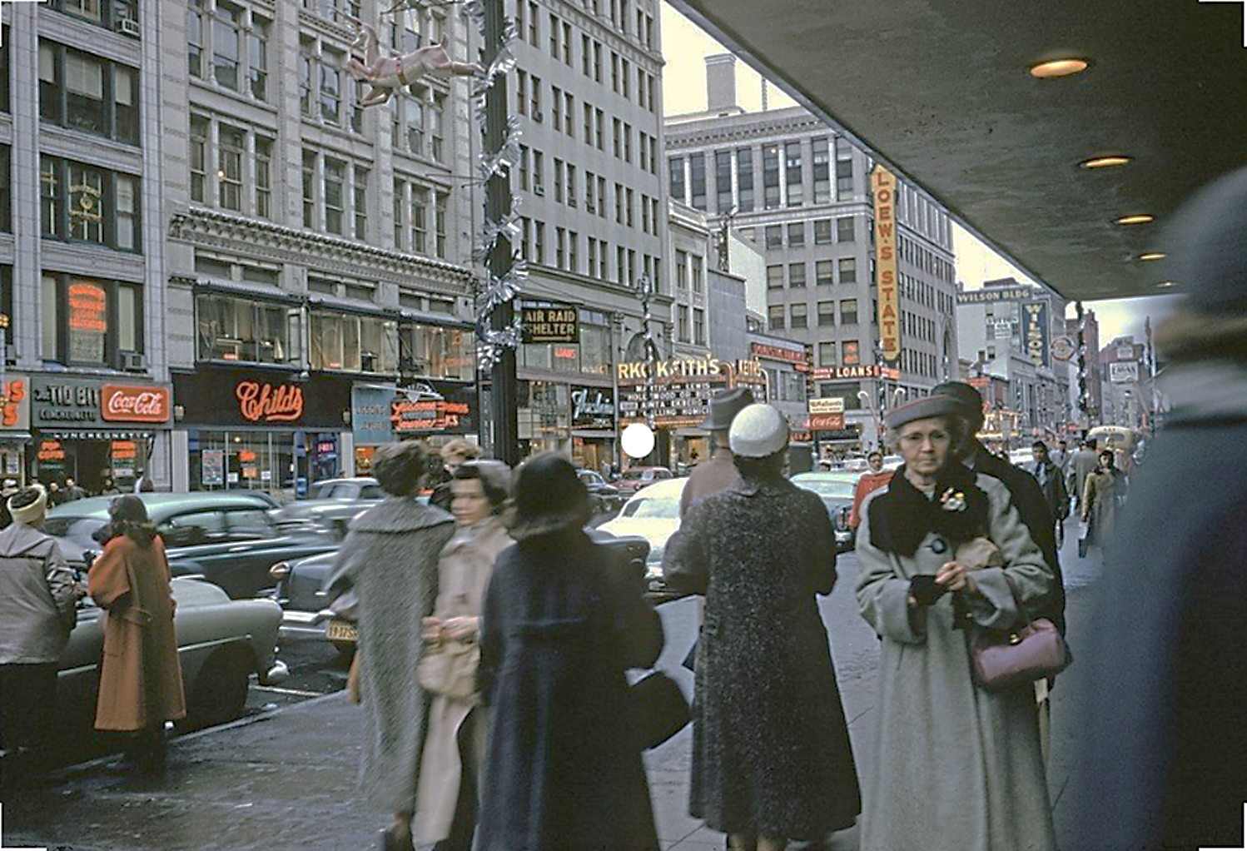
Source Investigation

- Identify what a person using your assigned “lens” would look for or notice.
- Record a question or questions a person using your assigned “lens” would ask or wonder about.

