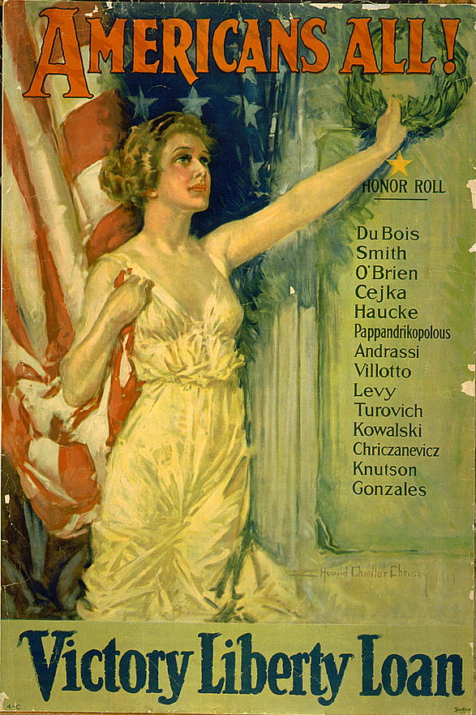

Americans All! Victory Liberty Loan
by Howard Chandler Christy (1873-1952); Forbes, Boston. 1919

