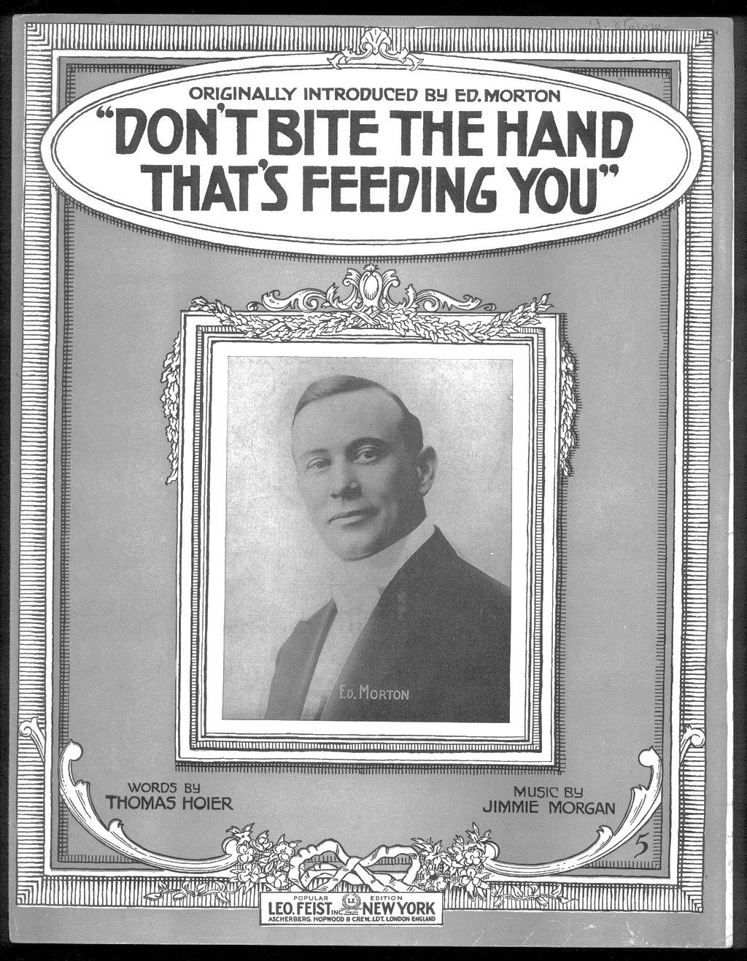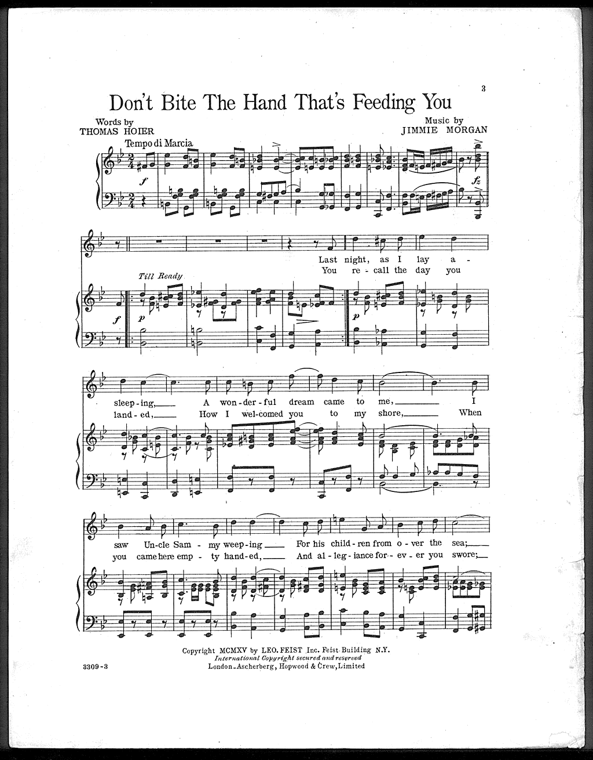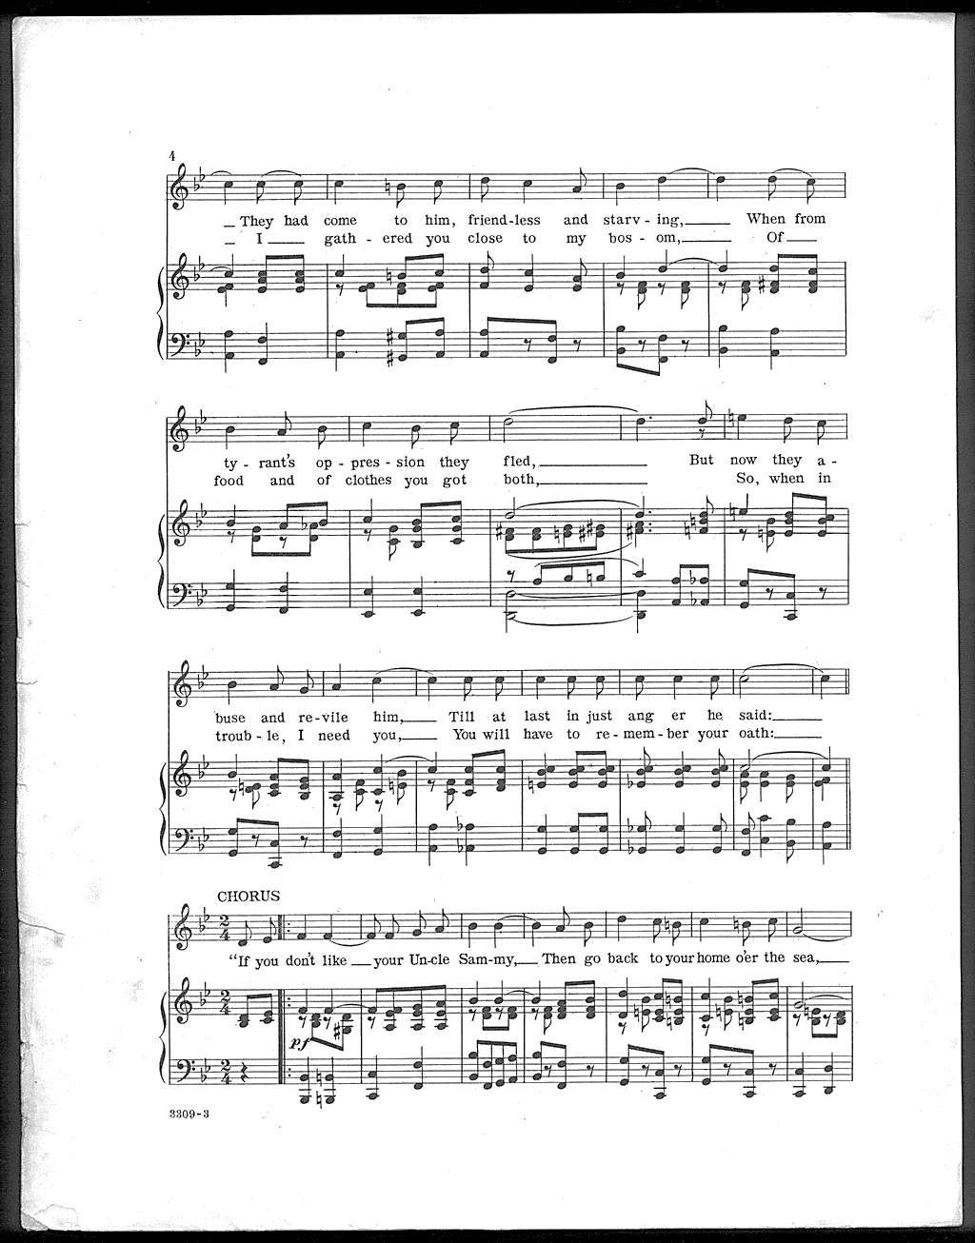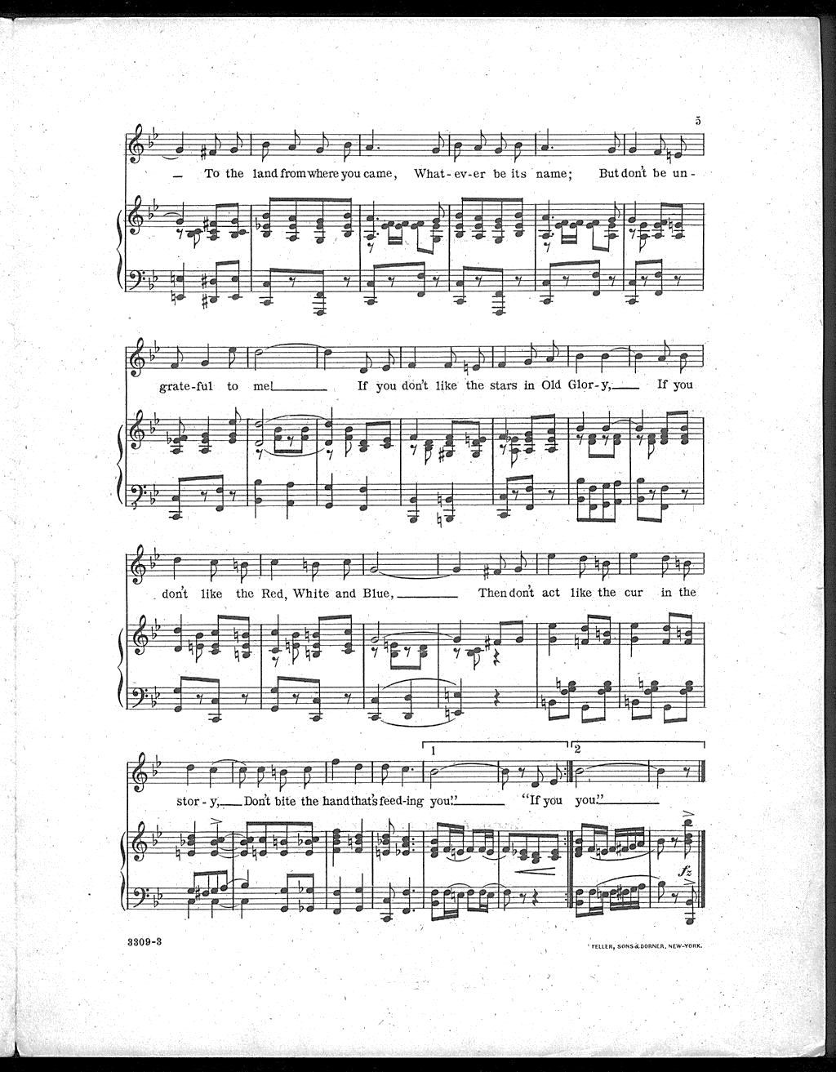

Morgan, Jimmie. Don’t Bite the Hand That’s Feeding You. Sheet Music. Orange, NJ: Edison, 1916. From Library of Congress, Inventing Entertainment: The Motion Picture and Sound Recordings of the Edison Companies. http://www.loc.gov/item/ihas.100007833

