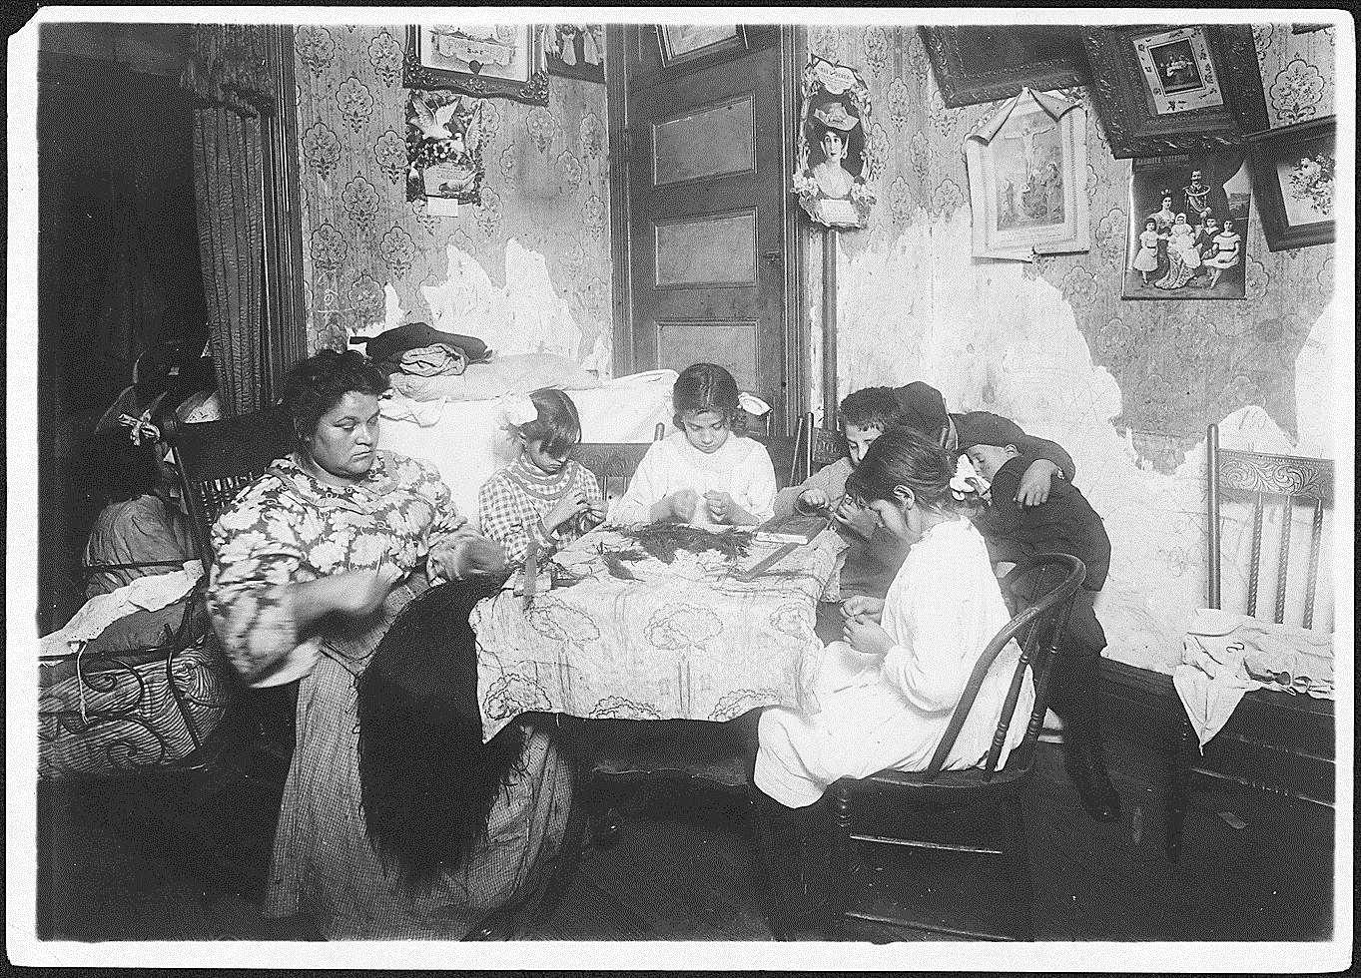
Lewis Hine, New York City, 1911
Mrs. Mauro, and family working on feathers, make $2.25 a week. In a vacation week, two or three times as much. Victoria, 8, Angeline, a neighbor, 10, Fiorandi, 10, Maggie, 11. Father is a street cleaner, and has a steady job. New York City. 12/19/1911

