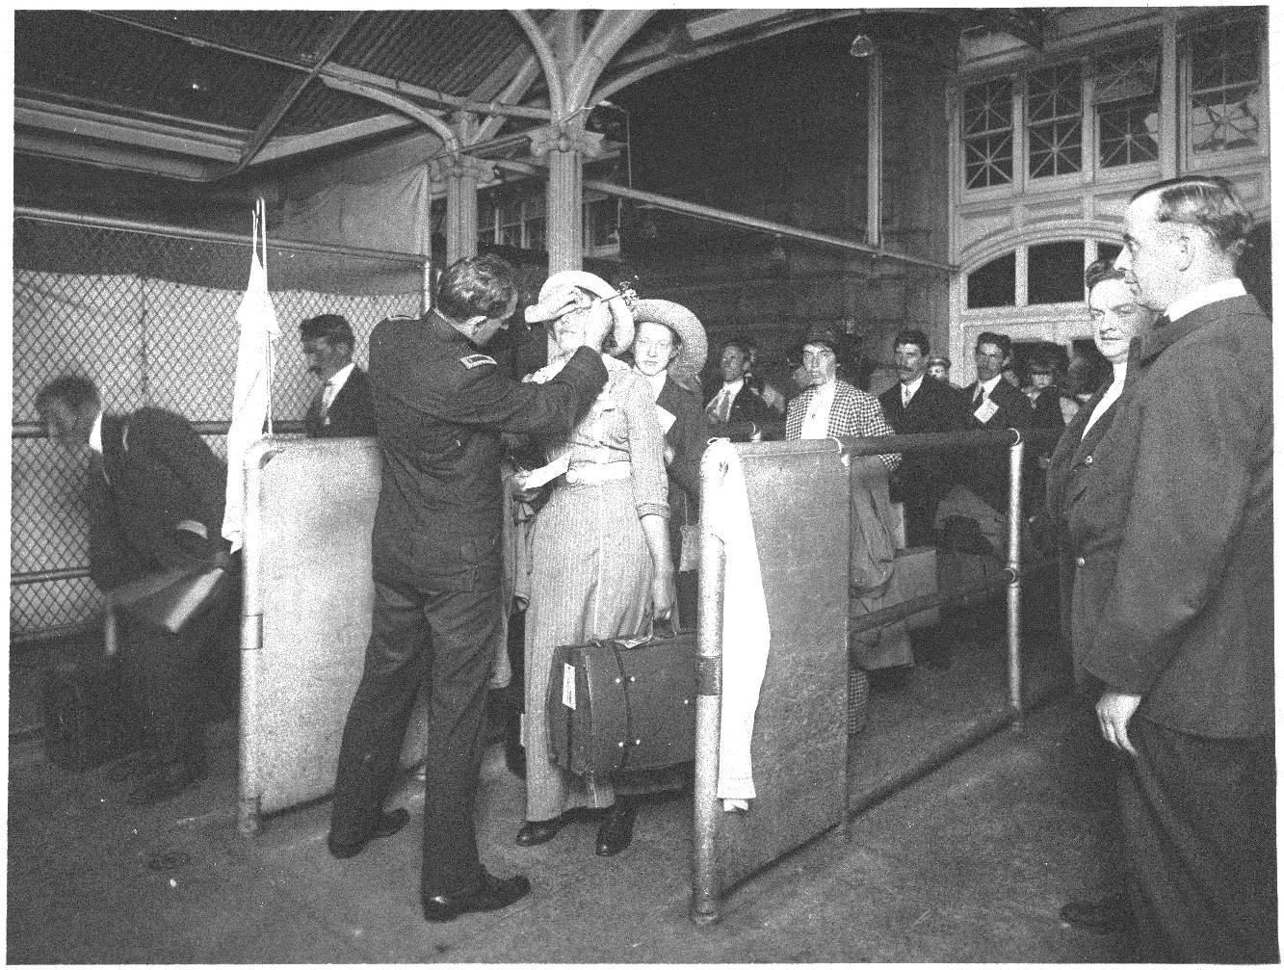
Health Exam in Ellis Island, N.Y., Early 20th Century
Doctors of the U.S. Public Health Service at Ellis Island often used a buttonhook device to check immigrants for trachoma, a highly contagious and difficult to cure eye disease.

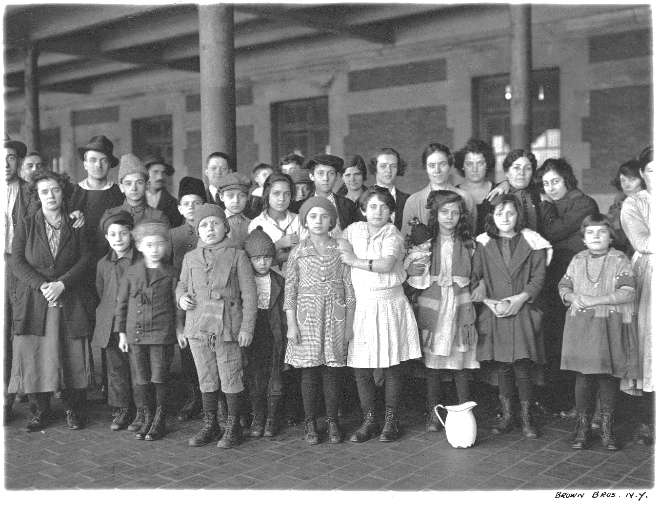
Immigrant children, Ellis Island, New York. By Brown Brothers, ca. 1908
Records of the Public Health Service.

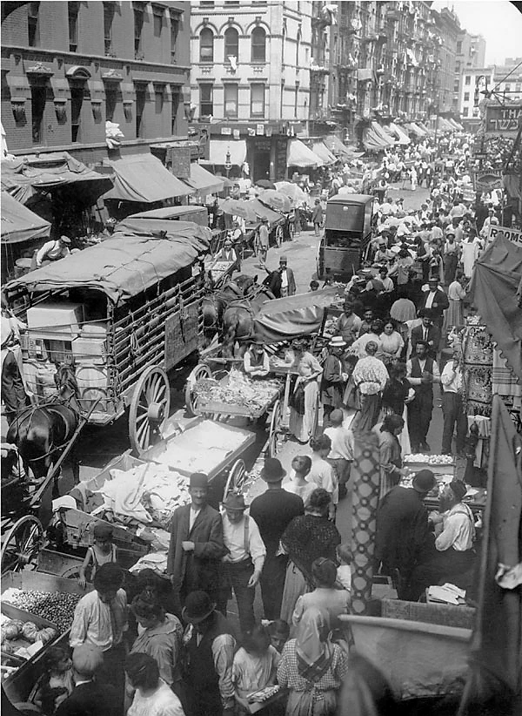

Lantern Slide of Hester Street, New York City, 1903
Hester Street is a street in the Lower East Side of the New York City borough of Manhattan. It has historically been a center for Ashkenazi Jewish immigrant culture.

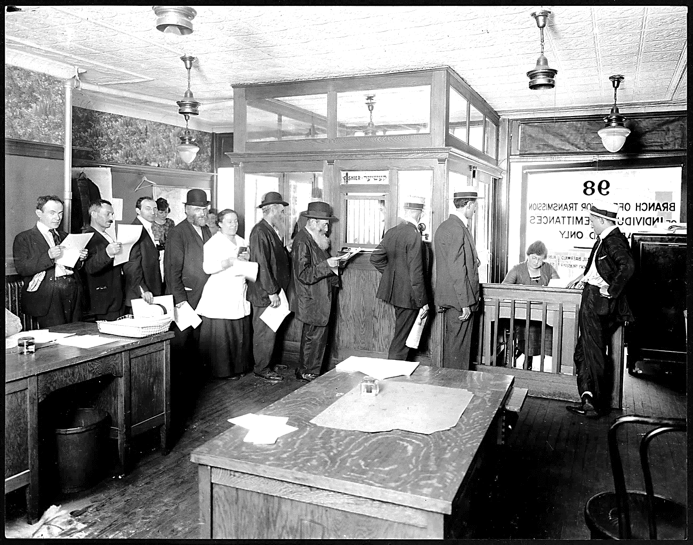

People in a Joint Distribution Committee Transmission Bureau to Send Money to Relatives Overseas, Around 1917-1918

During World War I, Americans who had relatives living in the war zones sought ways to send help to their families. In September 1915 the Joint Distribution Committee created a special Transmission Bureau as a vehicle through which families in America could transfer funds to their relatives trapped in war-torn countries. This branch office for the transmission of individual remittances was located at 98 Second Avenue, New York City, a neighborhood populated by immigrants.

