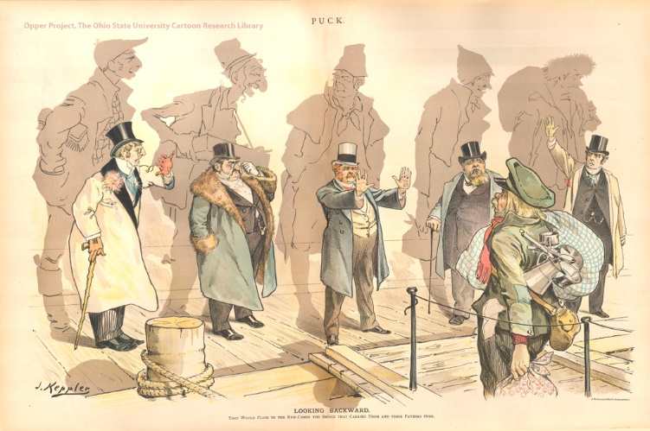

Looking Backward
They Would Close to the New-Comer the Bridge That Carried Them and Their Fathers Over.
By Joseph Keppler, published in Puck, January 11, 1893

Joseph Ferdinand Keppler (1838 - 1894) was an Austrian-born American cartoonist and caricaturist who greatly influenced the growth of satirical cartooning in the United States. Keppler also founded Puck, the first successful humor magazine in the United States of colorful cartoons, caricatures and political satire of the issues of the day. It was founded in 1871 as a German-language publication. It was published from 1871 until 1918. Puck's first English-language edition was published in 1877, covering issues like New York City's Tammany Hall, presidential politics, and social issues of late 19th century to early 20th centuries.

The Ohio State University, Billy Ireland Cartoon Library and Museum

