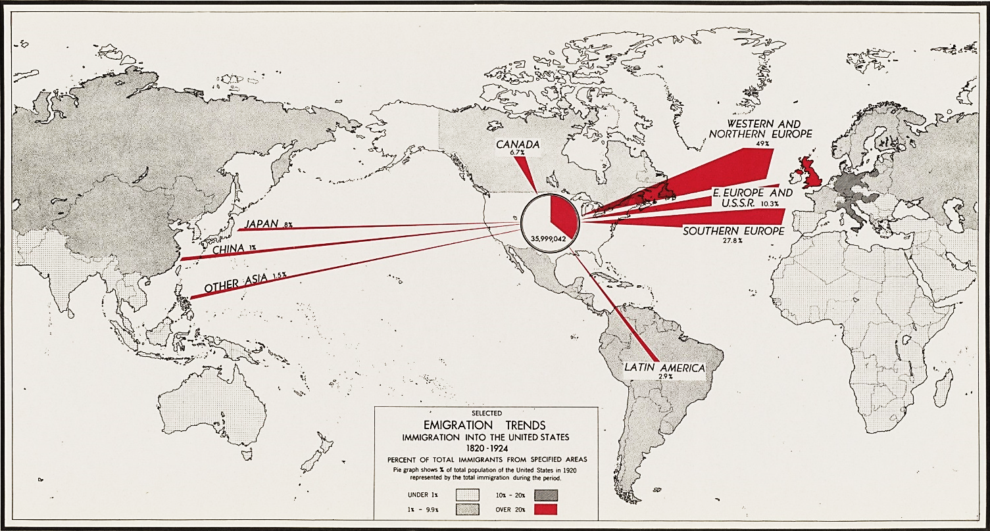

This comes from an Atlas of Population and Migration Trends created by the War Department that contains population, emigration, and immigration data from the 18th and 19th centuries, and population estimates to 1970.

Selected Emigration Trends Immigration into the United States 1820-1924, Percentage of Total Immigrants from Specified Areas; 1945; Records of the Office of Strategic Services, Record Group 226. [Online Version, https://www.docsteach.org/documents/document/selected-emigration-trends-immigration-into-the-united-states-18201924-percentage-of-total-immigrants-from-specified-areas, May 8, 2019]

