“Foreigners form a large percentage of the population of Syracuse. According to Boyd’s city directory there are about 30,000 of them out of a total of 134,835 inhabitants, or 22 per cent. These are distributed as follows: Germans, 8,900; Irish, 6,625; Italians, 5,000; Englishmen, 2,700; Canadians, 2,500; Polish, 1,500; Russians, 1,000; Norwegians, 400; Scotch, 400; Swiss, 210; French, 300; Austrians, 150; Swedes, 90; Danes, 75; Hungarians, 50; Chinese, 30.
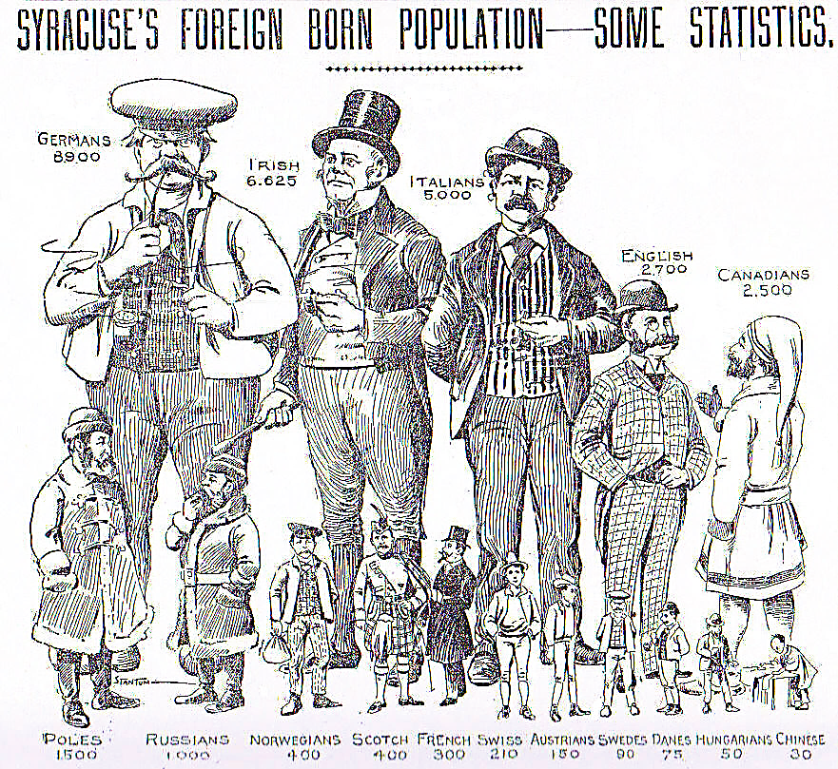
Deducting from this total the immigrants from Ireland, England, Scotland and Canada, there will still be left about 18,000 people, or 13 per cent who came from foreign countries where English is not spoken. It is interesting to note the gradual process of assimilation of these strangers in a strange land, and the very marked difference in the ease with which they acquire the English language. Considering the low degree of intelligence of a large class of immigrants, the wonder is not that they are so slow in learning English, but that they learn it at all. English offers one great advantage to the learner, in that it requires only about 500 words, properly selected, to carry on an ordinary conversation for every-day practical purposes, and these are to a great extent Anglo-Saxon words, easy to understand and to use. There are certain well-determined factors which control the acquisition of any foreign tongue. Language, like music or painting, is a special faculty and not altogether dependent upon a high degree of culture.”
By J. Loos, Syracuse Sunday Herald, 19 March 1897, page 28

