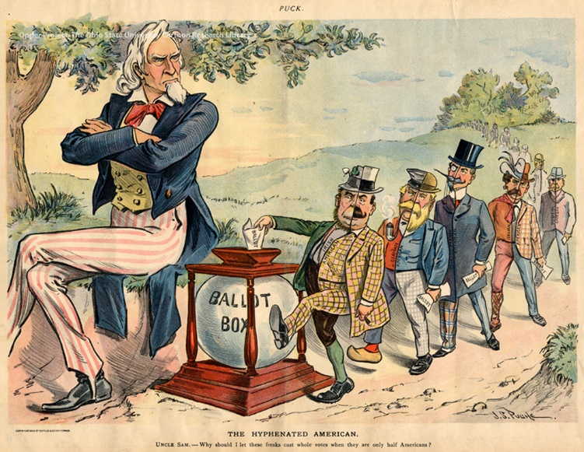

The Hyphenated American
Uncle Sam – Why should I let these freaks cast whole votes when they are only half Americans?
By J.S. Pughe, Published in Puck, August 9, 1899

John Samuel Pughe (1870-1909), was a Welsh-born American political cartoonist, best known for his illustrations for Puck magazine. Puck was the first successful humor magazine in the United States of colorful cartoons, caricatures and political satire of the issues of the day. It was founded in 1871 as a German-language publication. It was published from 1871 until 1918. Puck's first English-language edition was published in 1877, covering issues like New York City's Tammany Hall, presidential politics, and social issues of late 19th century to early 20th centuries.

The Ohio State University, Billy Ireland Cartoon Library and Museum

