The Immigration Restriction League, was founded in 1894 in Boston, and had branches in New York, Chicago, and San Francisco. The League used books, pamphlets, meetings, and numerous newspaper and journal articles to disseminate information and sound the alarm about the dangers of the new immigration.

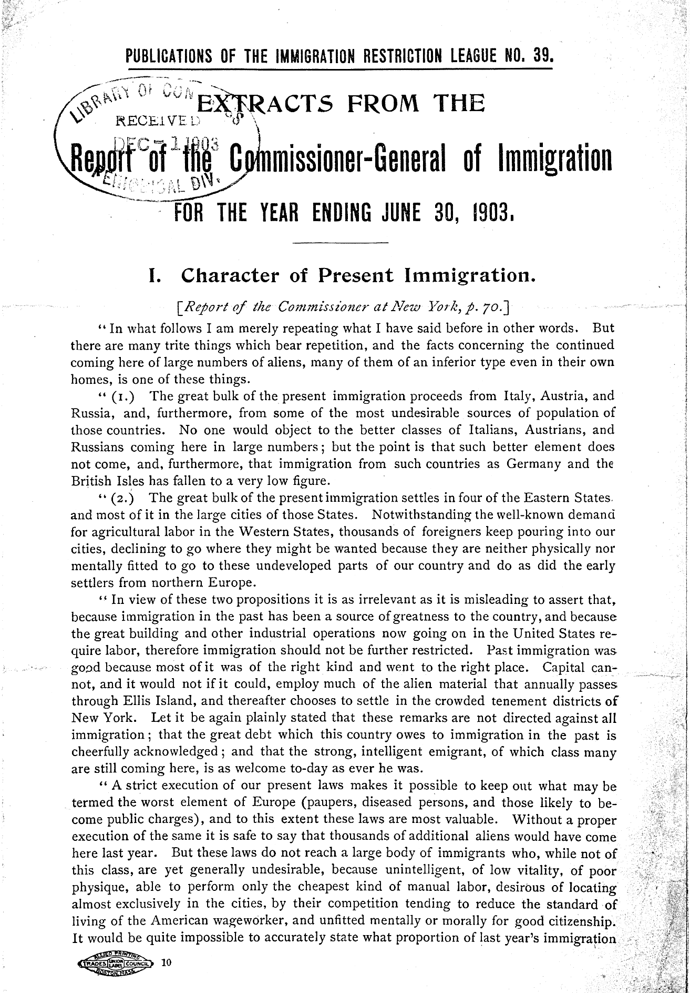

U. S. Commissioner-General Of Immigration. ... Extracts from the report of the Commissioner general of immigration for the year ending. 1903. Pdf. Retrieved from the Library of Congress, <www.loc.gov/item/rbpe.07902100/>.

